Data Science & Visualization (24ADI204)
WEEK 5 REPORT
Mid-Review: Data Audit & Initial Statistical Findings
Team 8
Academic Year 2026
Course Code: 24ADI204
Dataset: Ames Housing Dataset (Iowa, USA)

1. Introduction
This Week 5 report presents the Mid-Review Data Audit and Initial Statistical Findings for the Ames Housing dataset project under course 24ADI204 (Data Science & Visualization). Building upon the cleaning methodology established in Week 3, this report performs a rigorous audit of data quality, evaluates descriptive statistics, compares central tendency measures (mean vs. median), measures attribute dispersion and skewness, and identifies key numerical predictors of property sale prices.
2. Dataset Overview
The Ames Housing dataset contains comprehensive assessment records of residential properties in Ames, Iowa. The cleaned dataset evaluated in Week 5 consists of exactly 2,930 observations across 82 attributes (39 numerical and 43 categorical features). The target variable of interest is SalePrice ($).
3. Data Audit & Quality Verification
A systematic data audit was conducted to confirm dataset completeness, structural integrity, and proper formatting following the Week 3 cleaning sprint. The results are summarized below:
Audit Metric / Check | Actual Calculated Result
Total Rows (Observations) | 2,930
Total Columns (Attributes) | 82
Duplicate Rows | 0
Missing Values (Post-Cleaning) | 0
Numerical Features | 39
Categorical Features | 43

4. Missing Value and Duplicate Analysis
Following the domain-specific imputation applied in Week 3 (replacing amenity missingness such as no garage, pool, or basement with 'None' for categorical features and 0 for numerical dimensions, and imputing Lot Frontage via median), the Week 5 audit verified 0 remaining missing values across all 240,260 cells. Additionally, zero duplicate rows were detected.
5. Descriptive Statistics
Key continuous and discrete features were audited for central tendency, dispersion, quartiles, and interquartile range (IQR). Table 5.1 provides the empirical descriptive statistics:
Feature | Mean | Std Dev | Min | Q1 (25%) | Median | Q3 (75%) | Max | IQR
SalePrice ($) | 180,796.06 | 79,886.69 | 12,789.00 | 129,500.00 | 160,000.00 | 213,500.00 | 755,000.00 | 84,000.00
Gr Liv Area (sq ft) | 1,499.69 | 505.51 | 334.00 | 1,126.00 | 1,442.00 | 1,742.75 | 5,642.00 | 616.75
Overall Qual (1-10) | 6.09 | 1.41 | 1.00 | 5.00 | 6.00 | 7.00 | 10.00 | 2.00
Year Built | 1,971.36 | 30.25 | 1,872.00 | 1,954.00 | 1,973.00 | 2,001.00 | 2,010.00 | 47.00
Total Bsmt SF | 1,051.26 | 440.97 | 0.00 | 793.00 | 990.00 | 1,301.50 | 6,110.00 | 508.50
Garage Cars | 1.77 | 0.76 | 0.00 | 1.00 | 2.00 | 2.00 | 5.00 | 1.00
Garage Area (sq ft) | 472.66 | 215.19 | 0.00 | 320.00 | 480.00 | 576.00 | 1,488.00 | 256.00
1st Flr SF (sq ft) | 1,159.56 | 391.89 | 334.00 | 876.25 | 1,084.00 | 1,384.00 | 5,095.00 | 507.75

6. Mean, Median and Variability Analysis
Comparing mean and median provides critical insight into distribution symmetry. SalePrice has a mean of $180,796.06 and a median of $160,000.00. The mean exceeds the median by $20,796.06, demonstrating substantial positive (right) skewness caused by high-end luxury properties pulling the mean upward. In contrast, Overall Qual (mean 6.09 vs median 6.00) exhibits high symmetry.
7. Skewness Analysis
Skewness measures the degree of asymmetry in a feature's probability distribution:
1. • SalePrice (Skewness = +1.74): Strongly right-skewed, requiring log transformation during feature engineering.
2. • Gr Liv Area (Skewness = +1.27): Moderately right-skewed with high living area properties.
3. • 1st Flr SF (Skewness = +1.47): Positively skewed continuous area measurement.
4. • Lot Area (Skewness = +12.78): Extremely right-skewed due to massive acreage lots.
8. Correlation Analysis
Pearson correlation coefficients were computed across all numerical variables to determine primary linear predictors of property value:
Housing Feature | Pearson Correlation (r) with SalePrice
Overall Qual (Overall Material & Finish Quality) | +0.799
Gr Liv Area (Above Grade Living Area sq ft) | +0.707
Garage Cars (Garage Car Capacity) | +0.648
Garage Area (Garage Area sq ft) | +0.640
Total Bsmt SF (Total Basement Area sq ft) | +0.633
1st Flr SF (First Floor Area sq ft) | +0.622
Year Built (Original Construction Year) | +0.558
Full Bath (Full Bathrooms Above Grade) | +0.546
Year Remod/Add (Remodel / Addition Year) | +0.533
Mas Vnr Area (Masonry Veneer Area sq ft) | +0.502

9. Initial Statistical Findings
1. Target Distribution Asymmetry: SalePrice exhibits strong right skewness (+1.74) with a $20,796.06 gap between mean and median, reflecting market concentration in entry/mid-tier homes and heavy positive tails.
2. Material Quality Dominance: Overall Qual is the single strongest predictor of SalePrice (r = +0.799), showing non-linear price appreciation at quality levels 8, 9, and 10.
3. Spatial Scale Impact: Gr Liv Area is the dominant spatial predictor (r = +0.707). Each additional square foot of living space contributes positive market value.
4. Vehicle & Amenity Influence: Garage capacity (r = +0.648) and basement area (r = +0.633) serve as major structural value determinants.
5. Construction Modernity: Year Built (r = +0.558) confirms that newer construction commands significant market premiums over older homes.
6. Clean Dataset Readiness: The dataset contains exactly 2,930 clean records with zero missing entries and zero duplicates, ready for feature engineering.
10. Important Visualizations
Figure 10.1 displays the distribution of SalePrice alongside mean and median lines:
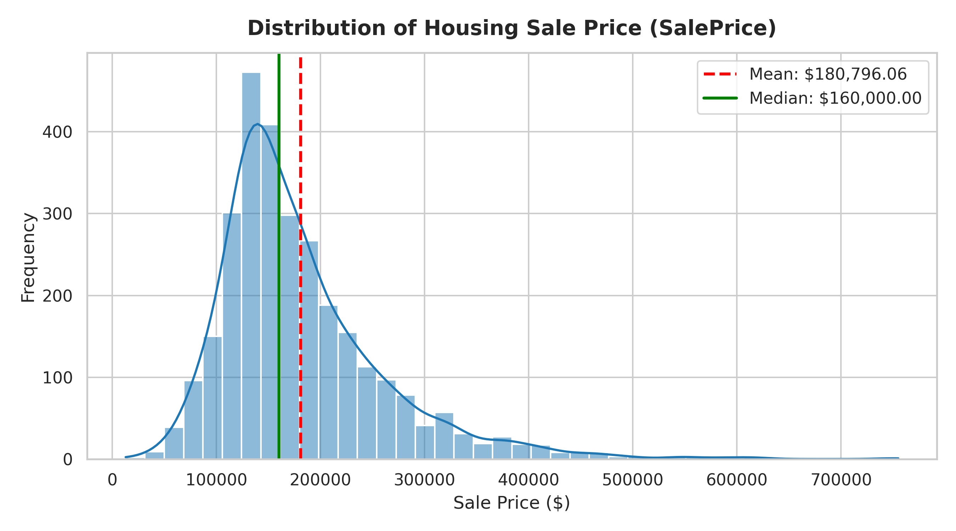
Figure 10.1: SalePrice Histogram with KDE, Mean, and Median
Figure 10.2 displays the correlation strength of top numerical attributes:
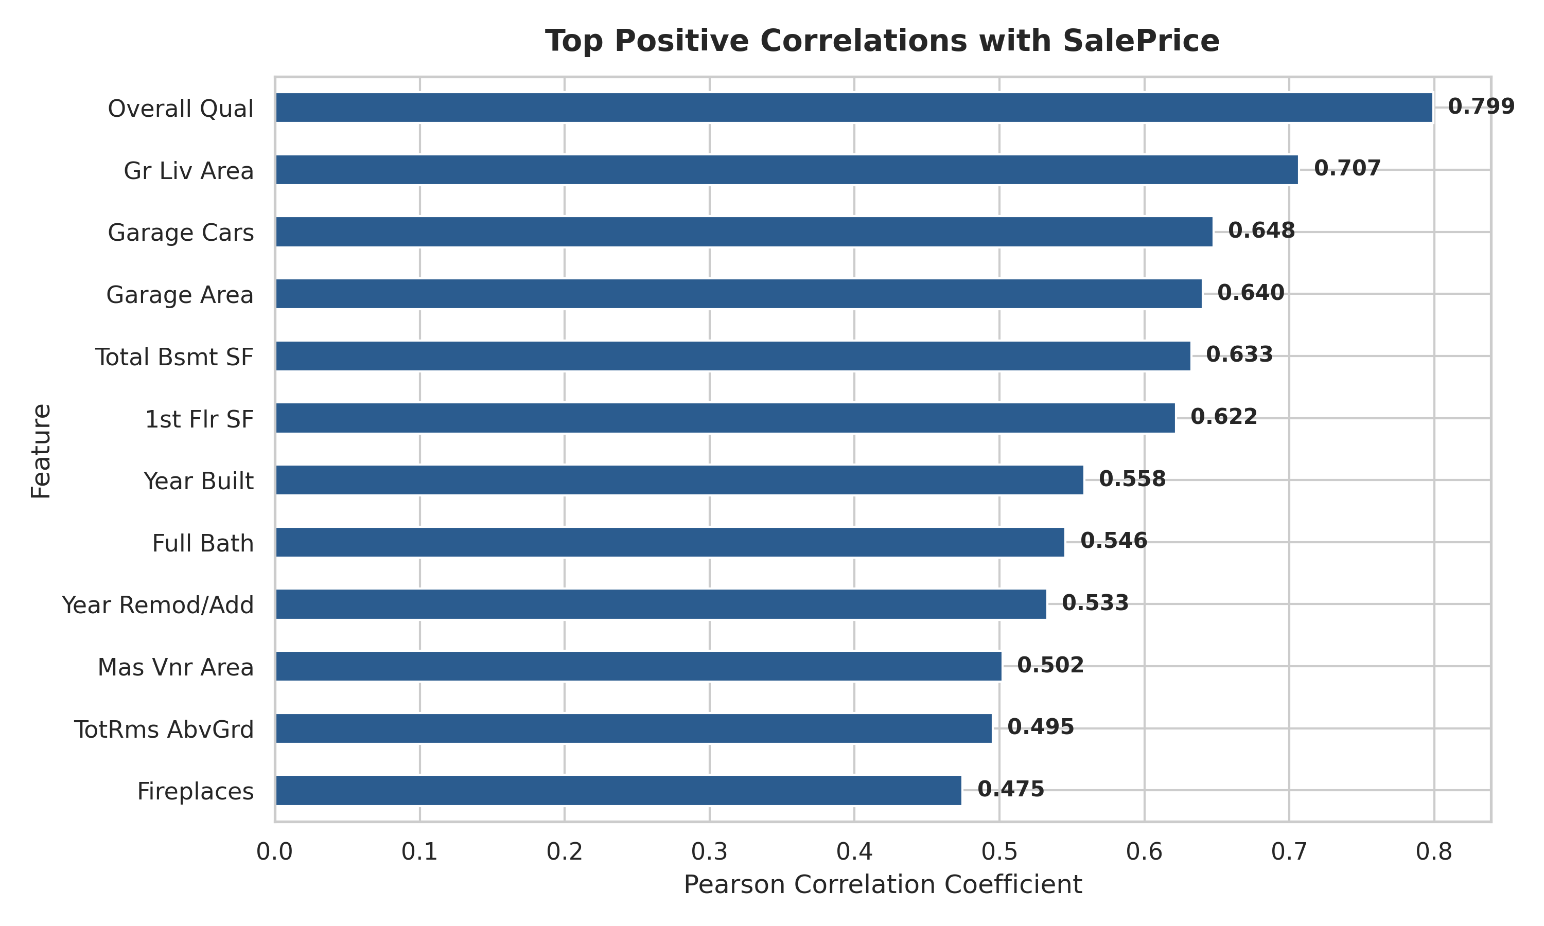
Figure 10.2: Top Positive Correlations with SalePrice
11. Conclusion
The Week 5 Data Audit successfully verified the cleanliness and statistical structure of the 2,930 property records. Key relationships, skewness characteristics, and correlations have been calculated and documented. This statistical audit sets a clean foundation for Week 6 Feature Engineering, where scaling, log transformations, and categorical encodings will be performed.

